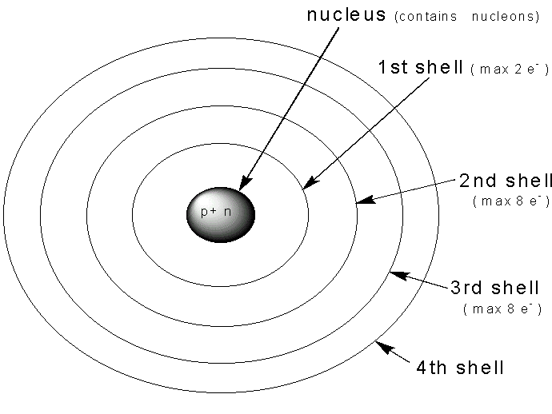
Creating Compounds – Worksheet 1.
As explained in the homework video, atoms want to be stable. To do this, they need to have the complete number of electrons in their outer-most electron shell. This is shown in the diagram below.
The first electron shell can hold 2 electrons.
The second electron shell holds 8 electrons.
The third electron shell holds 8 electrons.
The number in subsequent shells increases
with distance from the nucleus.

1. Complete the electron shell diagrams for the following atoms. Use your periodic table to determine the number of electrons in each.
(a) Lithium (b) Fluorine
2. How many electrons are in the outer-most How many electrons are in the outer-most shell
shell of Lithium? ____________ of Fluorine? __________
Will it be easier to lose or gain electrons Will it be easier to lose or gain electrons to
to obtain a full outside shell? ________________ obtain a full outside shell? _______________
How many will it need to gain or lose? _____ How many will it need to gain or lose? ________

3. What do these two atoms need to do to become happy? (Choose the correct statement below)
- They can not bond with each other to become happy.
- Lithium will give an electron to Fluorine to form LiF.
- Fluorine will give an electron to Lithium to form LiF.

4. Again using your periodic table, complete electron shell diagrams for these two atoms. Decide how they will bond to become happy and write the formula for their compound.
(a) magnesium (b) Oxygen
Formula = ____________
5. Repeat this process for atoms of Sodium and Oxygen.
Formula = ___________

